**Connecting machines using transist gateway and giving specific permission**

**Step 1 - Create 3 vpcs of cidr’s**

1. **10.10.0.0/20**
2. **10.10.16.0/20**
3. **10.10.32.0/20**

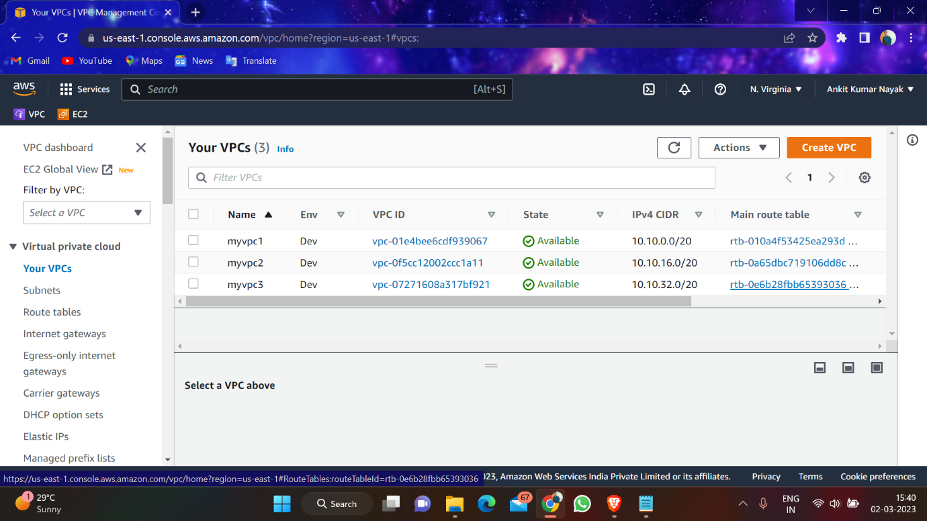

**Step 2 – Create 4 subnet, For the second vpc create 2 subnet one should be public and one should be private**

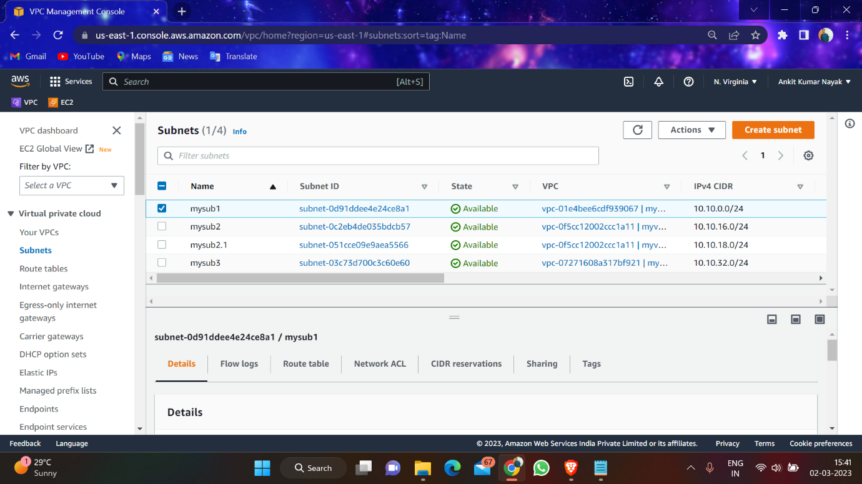

Step 4 – Create 4 route table, for 2nd route table create 2 route table and 1 attach internet gateway and other one don’t attch internet gateway

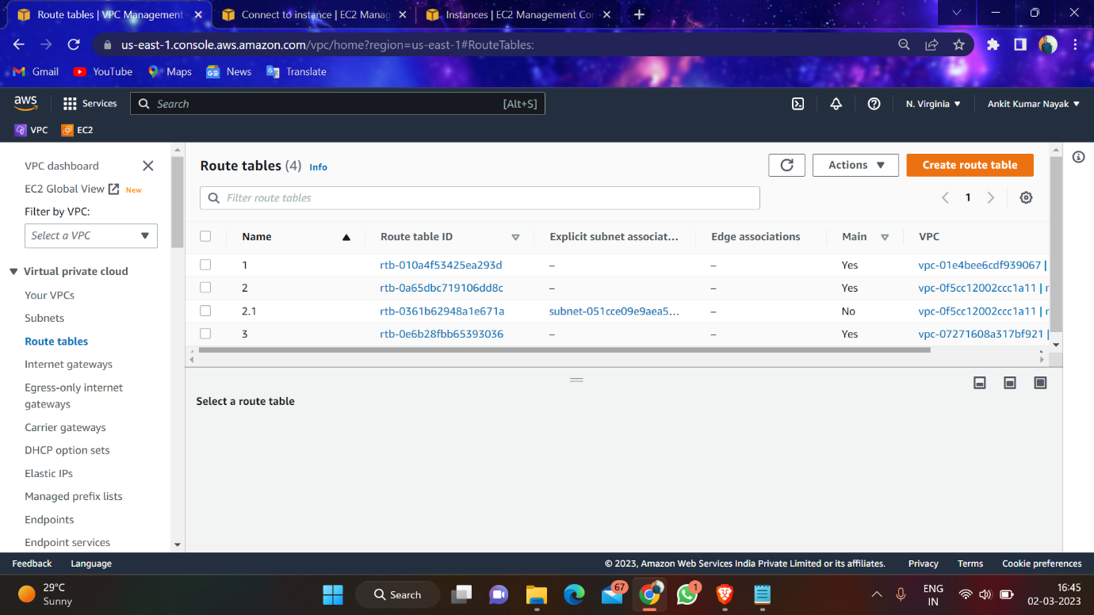

Step 5 – Create 3 internet gateway